This is a condition where a person’s blood pressure consistently remains high. There are usually no noticeable symptoms. In severe cases, symptoms may include: Headaches, dizziness, nosebleeds, vision changes. This condition can lead to serious health complications like heart attacks, strokes, and kidney failure if left untreated.
Hypertension Fact Sheet
What is Hypertension?

Non-modifiable: Things you cannot control
Age (increased risk with aging)
Family history of hypertension
Ethnic background (higher prevalence in African descent populations)

Modifiable: Things you can control
Unhealthy diet (high salt, low potassium intake)
Physical inactivity
Excessive alcohol consumption
Tobacco use
Being overweight or obese

Risk Factors

Prevention

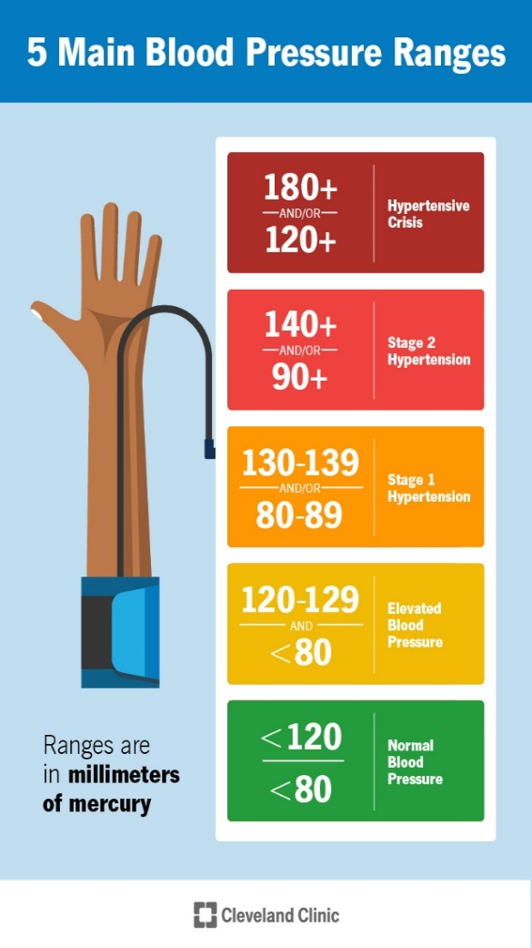
Management Tips:
- Track your blood pressure readings.
- Follow medication regimens as prescribed.
- Schedule regular check-ups with your doctor.
- Educate yourself about your condition and possible triggers.

Treatment:
- Lifestyle Changes:
  - Reduce salt intake
  - Increase physical activity
  - Maintain a healthy weight
  - Limit alcohol intake
  - Quit smoking
- Medications:
  - Prescribed by your doctor

*Maintain a balanced diet rich in
fruits, vegetables, and whole grains.
*Monitor blood pressure regularly.
*Engage in regular physical activity.
*Manage stress effectively.
*Avoid excessive sodium and
alcohol.

